Na

Old Bridge Historical Society
Third Annual Golf Tournament
Hole Sponsor
Oyster Bay Golf LInks August 7, 2024

Glen Dornoch

Name_____________________________________________________________

Address___________________________________________________________

City/State/Zip_______________________________________________________

Email_____________________________________ Phone__________________

Name/Wording you would like on your sign __________________________________________________________________

__________________________________________________________________

If you are a new sponsor and would like artwork/logo on your sign, please send your jpg file to: Ann Bokelman e.a.bokelman@gmail.com If you were a sponsor last year, we can use your sign again. Questions? Ann Bokelman 910-599-0034

Please send your check for $100.00 to Old Bridge Historical Society, C/O Ann Bokelman, 404 3rd St., Sunset Beach NC 28468

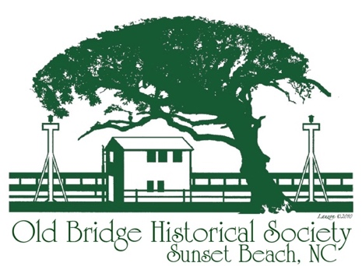
Thank you for being a hole sponsor! Your support is greatly appreciated!
OBHS is an all-volunteer 501(c)3 nonprofit.

